Report on Extension Activity
Extension Activity Name: “Awareness Drive on "Construction Material used in Civil Engineering"
Event Date: 12th April 2022 (Tuesday)
Event Venue/ Time: Village Chukhiara, Jalandhar Punjab from 10:00 AM to 2:00 PM
Organizing Unit/Agency: University Institute of Engineering Technology (Under the aegis of IQAC)
Subject: Awareness Program on Civil Engineering Construction Work
Department of Civil Engineering, Sant Baba Bhag Singh University, Jalandhar organized an extension activity in the form of “Awareness Program on Civil Engineering Construction Work” in collaboration with NGO (SOCIAL WELFARE AND AWARENESS SOCIETY HOSHIARPUR) in village Chukhiara, Punjab on 12/04/2022. Department of Civil Engineering showed great enthusiasm in interacting with the Village People students with different needs of Construction. Department of Civil Engineering, Sant Baba Bhag Singh University, Jalandhar were honoured with Appreciation award for his immense contribution in conducting the event. Nearly 50 plus peoples participated in this activity.
President of NGO, SOCIAL WELFARE AND AWARENESS SOCIETY and people of the Chukhiara Village appreciated the event and expressed hope that such events will be carried out in future as well.

Appreciated Letter from NGO
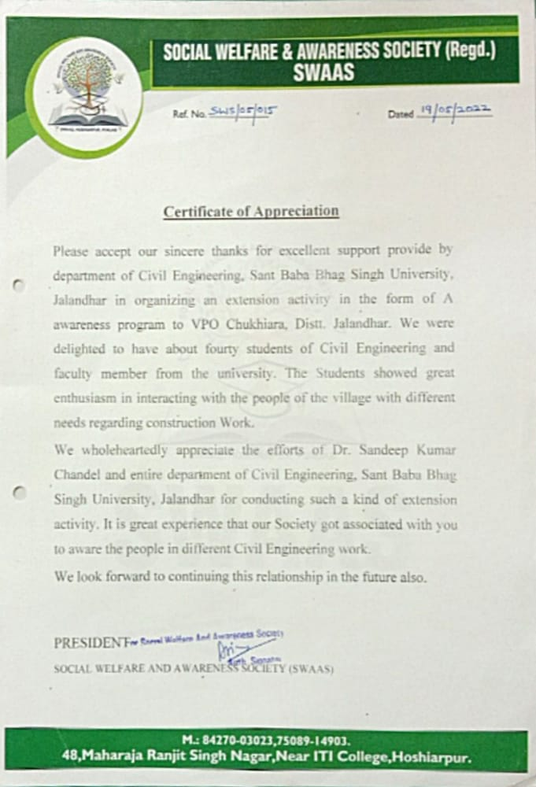

GLIMPSES OF EXTENSION ACTIVITY
